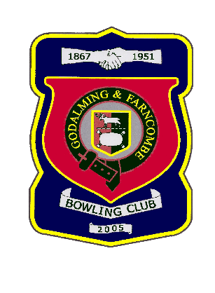 |  | Godalming & Farncombe Bowling Club  Saturday 19th June 2021 @ 2.30pm  WSL / Sapphire League  Home v Egham  Dress Whites  Please report to captain of day by 2.15pm
WSL |  |  |  | Sapphire League
1 | Norman Barber
2 | Martin Fishwick |  |  |  | 1 | Mariana Beadsworth
3 | Mark Rawlinson |  |  |  | 2 | Luis Pedra
skip | Tony Clark |  |  |  | skip | John Procter
1 | Robin Amy
2 | Gareth Williams |  |  |  | 1 | Sue Chruszcz
3 | Chris Eades |  |  |  | 2 | Les Easterling
skip | Alex Neil |  |  |  | skip | Roger Humphrey
1 | Ray Smith
2 | Peter Brown |  |  |  | 1 | Chelsea MacFarlane
3 | Bernie Gray |  |  |  | 2 | Brian Eades
skip | Graham Robinson |  |  |  | skip | Mac MacFarlane
Reserves: Ian Anderson
Captain of the day: |  |  |  | Contact on:
Martin Fishwick |  |  |  | 01483 421237

