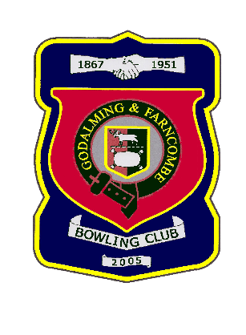 |  | Godalming & Farncombe Bowling Club  Sunday 20th June @ 2.30pm  Friendly  Home v Hindhead  Dress Greys  Please report to captain of day by 2.15pm
1 | Les Easterling |  |  |  | 1 | Mac MacFarlane
2 | Luis Pedra |  |  |  | 2 | John MacFarlane
skip | Jim Spring |  |  |  | skip | Barry Honeywill
1 | Robin Amy
2 | Bill Kelsey
skip | John Procter
Reserves: None
Captain of the day |  |  | Contact on
Barry Honeywill |  |  | 07711374184

