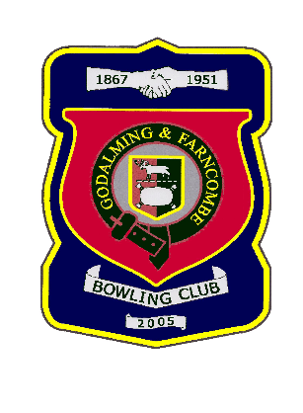 |  | Godalming & Farncombe Bowling Club  Tuesday 22nd June 2021 @ 6.30 pm  Three Counties League  Away v Haslemere  Dress Greys  Please report to captain of day by 6.15pm
1 | Ian Anderson |  |  |  |  | 1 | Mariana Beadsworth
2 | Roger Humphrey |  |  |  |  | 2 | John Procter
skip | Bernie Gray |  |  |  |  | skip | Jim Spring
1 | Sue Sims-Handcock
2 | Norman Barber
skip | Mark Lewis
Reserves:
Bill Kelsey, Jeanette Thomas, Martin Thomas, Robin Amy
Driver: |  |  | Taking:
Captain of the day |  |  |  | Contact on
Robin Amy |  |  |  | 07411 913664

