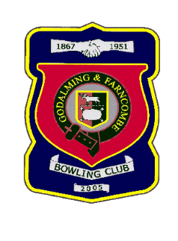 |  | Godalming & Farncombe Bowling Club  Saturday 18th September 2021 @ 2.30pm  Friendly  Home v East Horsley  Dress Whites  Please report to captain of day by 2.15pm
1 | Bill Kelsey |  |  |  | 1 | John Procter
2 | Sue Sims-Handcock |  |  |  | 2 | Tony Lloyd
skip | Mark Rawlinson |  |  |  | skip | Peter Brown
Reserves:
Captain of the day |  |  | Contact on
Peter Brown |  |  | 01483 421237

