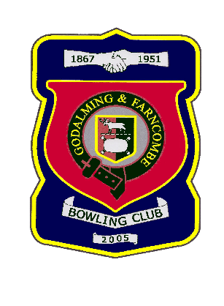 |  | Godalming & Farncombe Bowling Club  Saturday 2nd July 2022 @ 2.30pm  WSL / Sapphire League  AWAY v Cranleigh  Dress Whites  Please report to captain of day by 2.15pm
WSL |  |  |  |  | Sapphire League
1 | Robin Amy
2 | Martin Fishwick |  |  |  |  | 1 | Tom Ayshford
3 | Mark Rawlinson |  |  |  |  | 2 | Chelsea MacFarlane
skip | Tony Clark |  |  |  |  | skip | Roger Humphrey
1 | Chris Elliott
2 | Gareth Williams |  |  |  |  | 1 | Sally Eades
3 | Chris Eades |  |  |  |  | 2 | Brian Eades
skip | Alex Neil |  |  |  |  | skip | Jeanette Thomas
1 | Leon Hendry
2 | Mac MacFarlane |  |  |  |  | 1 | Hiliary Allen
3 | Barry Honeywill |  |  |  |  | 2 | Ama Neto
skip | Peter Brown |  |  |  |  | skip | Sue Sims-Handcock
Reserves:
Captain of the day: |  |  |  |  | Contact on:
Martin Fishwick |  |  |  |  | 01483 421237

