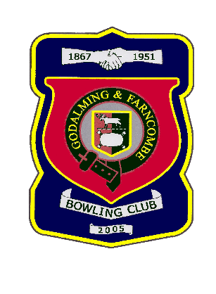 |  | Godalming & Farncombe Bowling Club  Sunday 3rd July 2022 @ 2.30pm  Friendly  HOME v Pyestock  Dress Whites  Please report to captain of day by 2.15pm
1 | Mike Horne |  |  |  | 1 | Hilary Allen
2 | Andy Awford |  |  |  | 2 | Rob Salter
skip | Peter Brown |  |  |  | skip | Robin Amy
1 | Lyn Gray |  |  |  | 1 | John Procter
2 | Peter Lawrence |  |  |  | 2 | Bill Kelsey
skip | Sue Sims-Handcock |  |  |  | skip | Barry Honeywill
Reserves: Mark Lewis
Captain of the day |  |  | Contact on
Peter Brown |  |  | 01483 425988…

