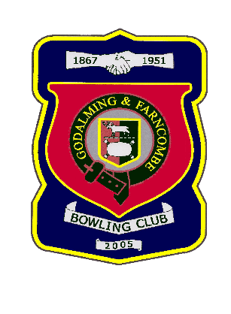 |  | Godalming & Farncombe Bowling Club  Tuesday 5th July 2022 @ 2.00pm  Guildford, Woking & District League  AWAY v Burpham  Dress Greys  Please report to captain of day by 1.45 pm
1 | Barry Honeywill |  |  |  | 1 |  | Mac MacFarlane
2 | Peter Brown |  |  |  | 2 |  | Martin Fishwick
skip | Alex Neil |  |  |  | skip |  | Tony Clark
Reserves:
Captain of the day: |  |  |  |  |  | Contact on:
Peter Brown |  |  |  |  |  | 01483 425988

