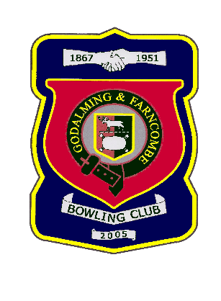 |  | Godalming & Farncombe Bowling Club  Sunday 21 April 2024 @2.30 pm  Friendly  HOME v Westfield  Dress Greys  Please report to captain of day by 2.15pm
1 | Adrian Deuling |  |  |  | 1 | Carol Bateman
2 | Michael Vernon |  |  |  | 2 | Lyn Gray
skip | Barry Honeywill |  |  |  | skip | Graham Robinson
1 | Bunty Vernon |  |  |  | 1 | June Smith
2 | Ray Smith |  |  |  | 2 | Les Easterlimg
skip | Jim Spring |  |  |  | skip | Robin Amy
Reserves:
Captain of the day |  |  | Contact on
Jim Spring |  |  | 01252 702635

