GFBC January 2025 update.

1. Club Night continues Wednesday evenings at Spoons.
2. A reminder that, in line with the clubs constitution, we need to hear from full or prospective full members, that they intend to join the club for the coming season by paying a deposit of £20 before the 31st January 2025. You can of course pay in full. Thank you to those who have already paid in full or made that deposit (you now have until the end of March to pay in full).

Social members can pay any time prior the club opening.

1. We are entering the usual Surrey/West Surrey leagues. Chris needs your Surrey competition by the first week in February this year so he can collate and then let me know. I must submit the comps at the same time as affiliations which closes 28th February.

Email from chriseades7@gmail.com

Hi all, happy new year

It’s that time of the year where I ask you all if you wish to enter any county competitions for the new season.

We have the full assortment for men and ladies of singles, 2 woods (played on 13th July) , pairs, triples, fours, unbadged, officers, CoC, seniors and mixed pairs/fours.

County competitions are a great way of playing competitively against other initially local players before branching out to wider clubs in the latter rounds. I would encourage you all to consider entering as you will enjoy it!

Please let me know what you wish to enter and start arranging any teams now.

We will have a lot of members happy to team up so am happy to help build some teams if you want to put your name in the hat.

Thanks Chris

1. Three Counties Bowls Fellowship. We are entering our usual league. If you want to enter any of their competitions you need to let Robin know before the 3rd February, he submits them on the 11th.
2. Ladies West Surrey Comps to Lyn by the 3rd April as they have to be in by the 11th April.
3. West Surrey Comps will more than likely be around the same time but they are yet to announce the date.
4. Club 50/50 drawn each of the 12 months. 3 prizes from the 50% with the extra held over each month for a big draw at Xmas. The numbers of members has dropped off, so new members welcome, It’s organised by Martin Thomas.
5. Jumble Sale is on 8th March, goods can be taken down the club at any time. You’ll see the storing area on your right in the dining room.
6. This is the design of the new club shirt; after discussion with the supplier, the blue may be darker. This will help match with lower half colours which we will decide next season. In the meantime, we’ll carry on with white and grey.

We are hoping that sample sizes will arrive by the weekend, so I will notify **when** you can attend the club to try on and record your selected size. We have also been told that if you want your name thereon, it will be dyed into the fabric and not printed. This is a good option.

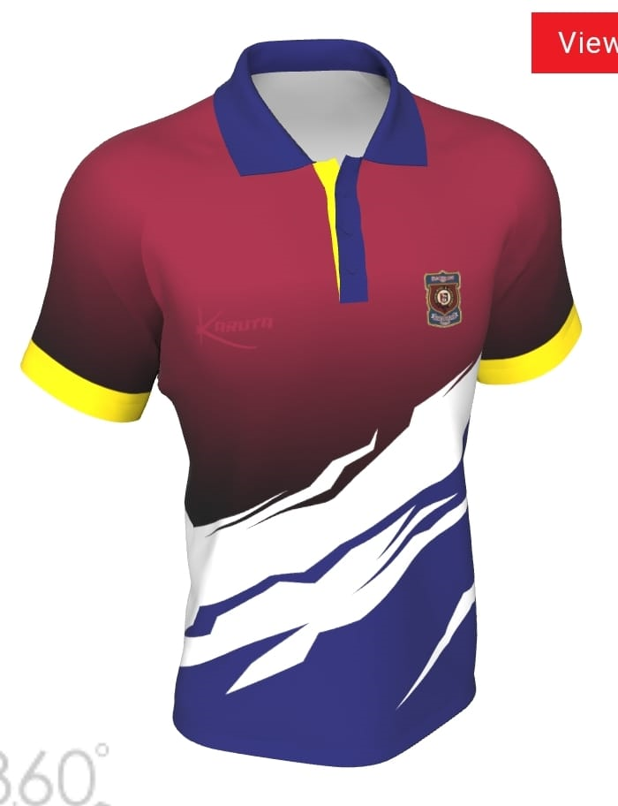

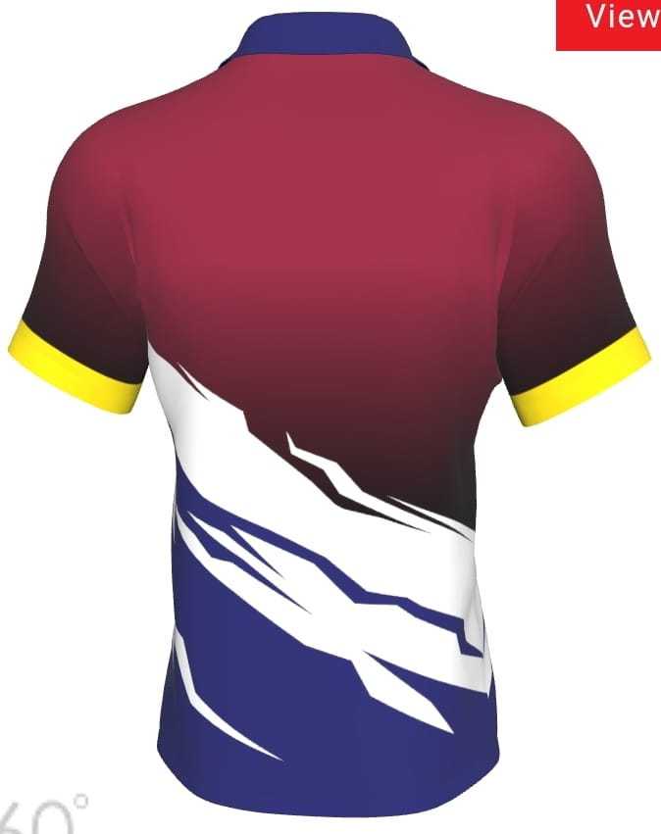

GFBC Hon Sec.

If you were a member last year and don’t intend to rejoin, please let me know.