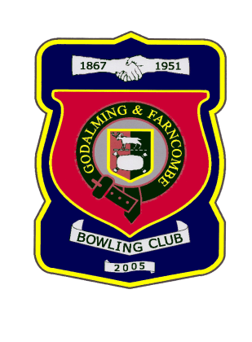

Godalming & Farncombe Bowling Club
(Affiliated to Bowls England, SCBA and the WSBA)
President – J Spring Esq.
website – http://www.gobo.org.uk

Hon Secretary Hon Treasurer
Barry Honeywill Peter Brown
Home 01483 425988
Mobile 07711 374184 Mobile 07834 561370
email gfbcsec@gmail.com email petlie786@yahoo.co.uk

APPLICATION FOR JUNIOR MEMBERSHIP

To be certain that G&FBC complies with legal changes designed to protect your privacy, we are asking for your consent to hold personal data you provide below.
We would like to be able to contact you by different means and allow other members to contact you if required. Please tick the boxes below to give your consent.

Post Phone Email Text

Your Personal data will be retained as long as you are a member. We will delete it within 3-months of you ceasing to be a member. Your data will be stored on computer. Paper copies, where required, will be stored securely at the Club. We will never sell your data and will not share it unless required by law to do so, or in accordance with the consent we ask you to give below
I Junior Member …………………………………………………………………………………………….
Parent …………………………………………………………………………………………………………….
(Parent Name and Address in block letters please)
………………………………………………………………………………………………………………………………………….
………………………………………………………………………………………………………………………………………….
………………………………………………………………………………………………………………………………………….
Post Code……………………Phone…….………………… Junior Member Date of Birth…………………..
Email……………………………………………………………………… Mobile ………………………………………….
Contact in case of Emergency………………………………………Phone…………………………………………..

Wish to become a Junior Member of Godalming & Farncombe Bowling Club and to promote the interests of the Club at all times

Please state briefly any previous experience and details of previous bowling clubs that you have belonged to:-
…………………………………………………………………………………………………………………………………………………………………………………………………………………………………………………………………………………………………………………………………………………………………….........................................................

I understand that on acceptance I will be expected to comply with Club Rules and Regulations as published.

Parental Signature ……………………………………………………...……Date ……………………………………………

Proposed by ……………………………………………………Seconded by ……………………………………………...…

Block Letters………………………………………………….. Block Letters …………………………………………........

