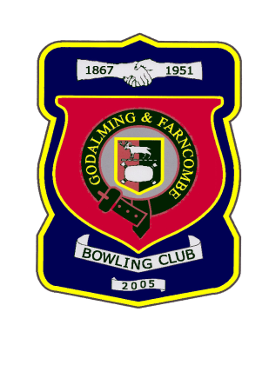Godalming and Farncombe Bowling Club

(Affiliated to Bowls England, SCBA and the WSBA)

President – J Spring Esq.

website – <http://www.gobo.org.uk>

*Hon Secretary Hon Treasurer*

**Barry Honeywill** **Peter Brown**

Mobile 07711 374184           Mobile 07834 561370

e-mail [gfbcsec@gmail.com](mailto:gfbcsec@gmail.com)              email [petlie786@yahoo.co.uk](mailto:petlie786@yahoo.co.uk)

**AGM**

NOTICE IS HEREBY GIVEN that the ANNUAL GENERAL MEETING of the GODALMING & FARNCOMBE BOWLING CLUB will be held on

WEDNESDAY 29th OCTOBER 2025 at 7.00pm

in the CLUB HOUSE**.**

ONLY FULL MEMBERS ARE ALLOWED TO VOTE.

SOCIAL MEMBERS ARE WELCOME TO ATTEND BUT NOT VOTE.

Officer nominations are invited – the list is on the main notice board, usual spot (displayed since 3/9/25).

Any members wishing to include items on the agenda must notify the Secretary before 1st October 2025 as per the constitution. Please do so well in advance of this to allow the secretary to carry out any necessary work.

Agenda to follow on the 15th October 2025. The meeting will only discuss items on the agenda; no deviation is permitted.

Barry Honeywill

Hon Secretary  
1/10/2025