**SATURDAY 22nd November**

**6.30 for 7.00**

* Just £20 per head *(price held for a third year)* for a ‘Jackie Special’ dinner, including wine, coffee, mince pies … • See off the season in style

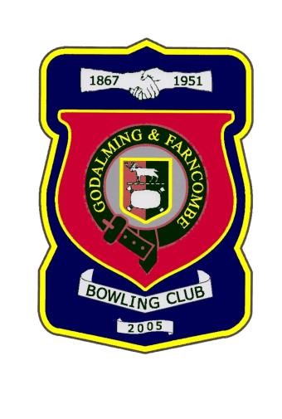

Come and join us, and support your club on

* Evening dress optional!
* Payment to Jackie in advance if possible, or on the night
* Please sign up on the list on the notice board

*Or message Robin and he’ll do it for you*

Thank you