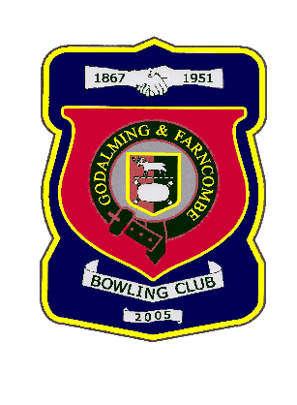 |  | Godalming & Farncombe Bowling Club  Tuesday 12th May @ 6.15 pm  Three Counties League  AWAY v Cranleigh B  Please report to captain of day by 6.00pm
1 | Judith Davis |  |  |  | 1 | Dave Jenner
2 | Les Easterling |  |  |  | 2 | Roger Humphrey
skip | Robin Amy |  |  |  | skip | Chelsea MacFarlane
1 | Peter Mills
2 | Jeanette Thomas
skip | Bernie Gray
Reserves:
Captain of the day |  |  | Contact on
Robin Amy |  |  | 07411 913664

