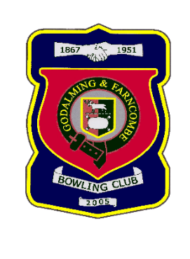 |  | Godalming & Farncombe Bowling Club  Thursday30th April @2.30 pm  Knaphill League  AWAY v Wonersh  Please report to captain of day by 2.15pm
1 | Peter Brown |  |  |  | 1 | Judith Davies
2 | Linda Rixon |  |  |  | 2 | Jackie Spring
skip | Robin Amy |  |  |  | skip | Jim Spring
Reserves:
Captain of the day |  |  | Contact on
Peter Brown |  |  | 07834561370

