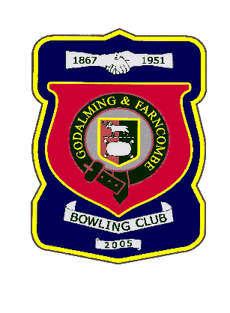 |  | Godalming & Farncombe Bowling Club  Tuesday 5th May @ 6.15pm  Three Counties League  HOME v Rogate  Please report to captain of day by 6.00pm
1 | Mike Hobbs |  |  |  | 1 | Andy Foreman
2 | Michael Vernon |  |  |  | 2 | Roger Humphrey
skip | Jim Spring |  |  |  | skip | Bernie Gray
1 | Jackie Spring
2 | Jeanette Thomas
skip | Chelsea MacFarlane
Reserves:
Robin Amy, Dave Jenner, Judith Davis
Captain of the day |  |  |  | Contact on
Jim Spring |  |  |  | 07789 143178

