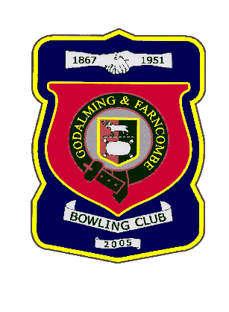 |  | Godalming & Farncombe Bowling Club  Thursday 7thMay @2.30 pm  Knaphill League  HOME v Milford  Please report to captain of day by 2.15pm
1 | Judith Davis |  |  |  | 1 | Linda Rixon
2 | Dave Jenner |  |  |  | 2 | Peter Mills
skip | Jim Spring |  |  |  | skip | Robin Amy
Reserves:
Captain of the day |  |  | Contact on
Robin Amy |  |  | 07411913664

