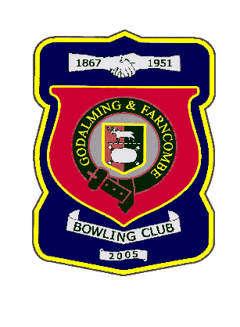 |  | Godalming & Farncombe Bowling Club  Tuesday 2nd June @ 6.30 pm  Three Counties League  HOME v Petersfield B  Please report to captain of day by 6.15 pm
1 | Judith Davis |  |  |  | 1 | Andy Foreman
2 | Jackie Spring |  |  |  | 2 | Roger Humphrey
skip | Chelsea MacFarlane |  |  |  | skip | Jim Spring
1 | Les Easterling
2 | Michael Vernon
skip | Robin Amy
Reserves:
Dave Jenner, Peter Mills
Captain of the day |  |  |  | Contact on
Robin Amy |  |  |  | 07411 913664

