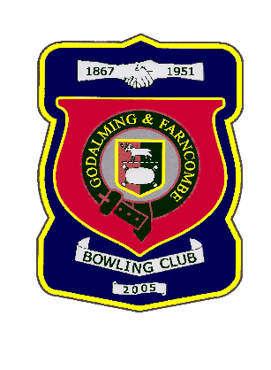 |  | Godalming & Farncombe Bowling Club  Tuesday 26th May @ 2.00pm  Guildford, Woking & District League  HOME vBurpham  Please report to captain of day by 1.45 pm
1 | Peter Brown |  |  | 1 |  | Ray Smith
2 | Barry Honeywill |  |  | 2 |  | Martin Fishwick
skip | Rob Boxall |  |  | skip |  | Robin Amy
Reserves:
Captain of the day: |  |  |  |  | Contact on:
Peter Brown |  |  |  |  | 07834561370

