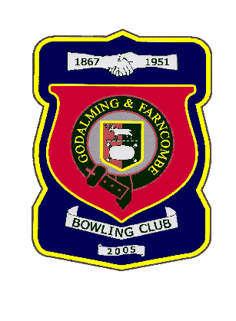 |  | Godalming & Farncombe Bowling Club  Tuesday 26th May @ 6.30 pm  Three Counties League  AWAY v Hindhead  Please report to captain of day by 6.15 pm
1 | Dave Jenner |  |  |  | 1 | Mike Hobbs
2 | Roger Humphrey Les E |  |  |  | 2 | Robin Amy
skip | Bernie Gray |  |  |  | skip | Jim Spring
1 | Judith Davis
2 | Jackie Spring
skip | Nicola Gray
Reserves:
Easterling, Andy Foreman, Michael Vernon
Captain of the day |  |  | Contact on
Robin Amy |  |  | 07411 913664

