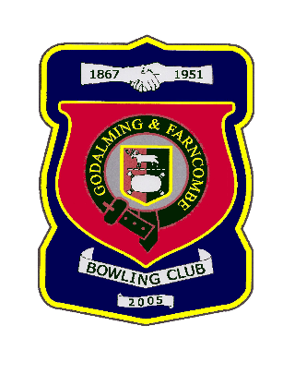 |  | Godalming & Farncombe Bowling Club  Tuesday 16th June @ 6.30 pm  Three Counties League  AWAY v Sutton  NB This is the Sutton in West Sussex, South of Petworth  Please report to captain of day by 6.15 pm
1 | Dave Jenner |  |  |  | 1 | Les Easterling
2 | Michael Vernon |  |  |  | 2 | Jackie Spring
skip | Jim Spring |  |  |  | skip | Robin Amy
1 | Mike Hobbs
2 | Peter Mills
skip | Bernie Gray
Reserves:
Captain of the day |  |  | Contact on
Robin Amy |  |  | 07411 913664

