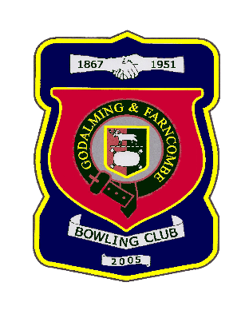 |  | Godalming & Farncombe Bowling Club  Tuesday 23rd June @ 6.30 pm  Three Counties League  AWAY v Rogate  Please report to captain of day by 6.15 pm
1 | Mike Hobbs |  |  |  | 1 | Dave Jenner
2 | Les Easterling |  |  |  | 2 | Judith Davis
skip | Chelsea MacFarlane |  |  |  | skip | Nicola Gray
1 | Peter Mills
2 | Roger Humphrey
skip | Bernie Gray
Reserves:
Jim Spring, Jackie Spring, Robin Amy
Captain of the day |  |  | Contact on
Chelsea MacFarlane |  |  | Robin on 07411 913664

