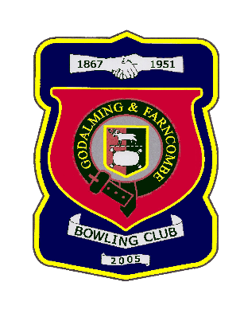 |  | Godalming & Farncombe Bowling Club  Tuesday 7th July @ 6.30 pm  Three Counties League  AWAY v Holloway Hill  Please report to captain of day by 6.15 pm
1 | Mike Hobbs |  |  |  | 1 | Dave Jenner
2 | Michael Vernon |  |  |  | 2 | Adrian Deuling
skip | Chelsea MacFarlane |  |  |  | skip | Bernie Gray
1 | Carol Bateman
2 | Jeanette Thomas
skip | Nicola Gray
Reserves:
Roger Humphrey, Les Easterling, Robin Amy
Captain of the day |  |  | Contact on
Chelsea MacFarlane |  |  | 07359 174099

