Newsletter No 6
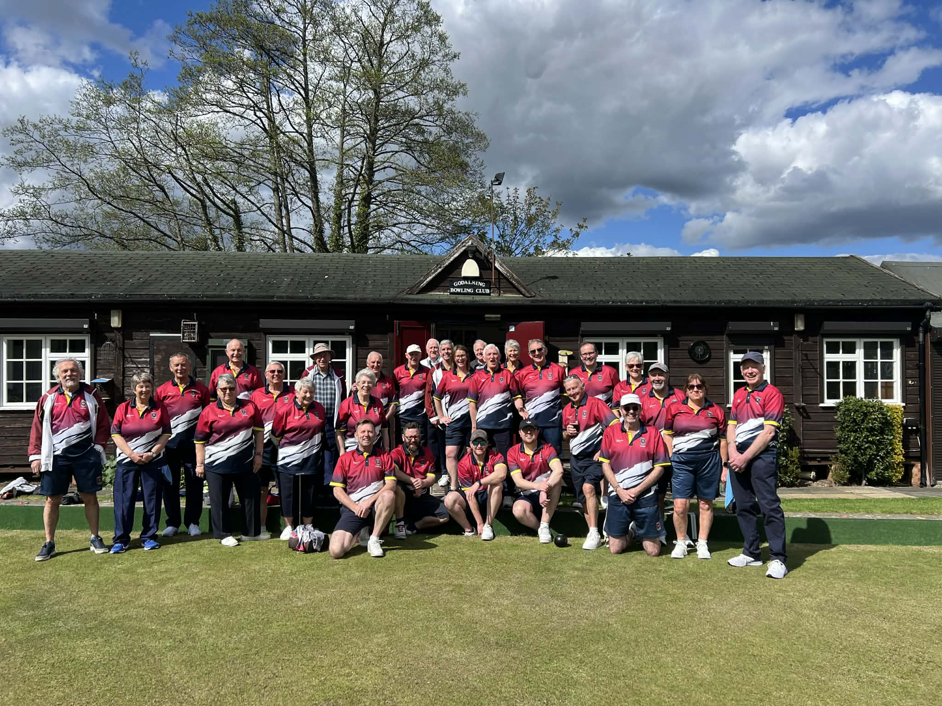

Opening drive :
It was nice to see so many players at the opening drive, over 30. Lots of laughing, chatting and an abundance of excitement for the new season.

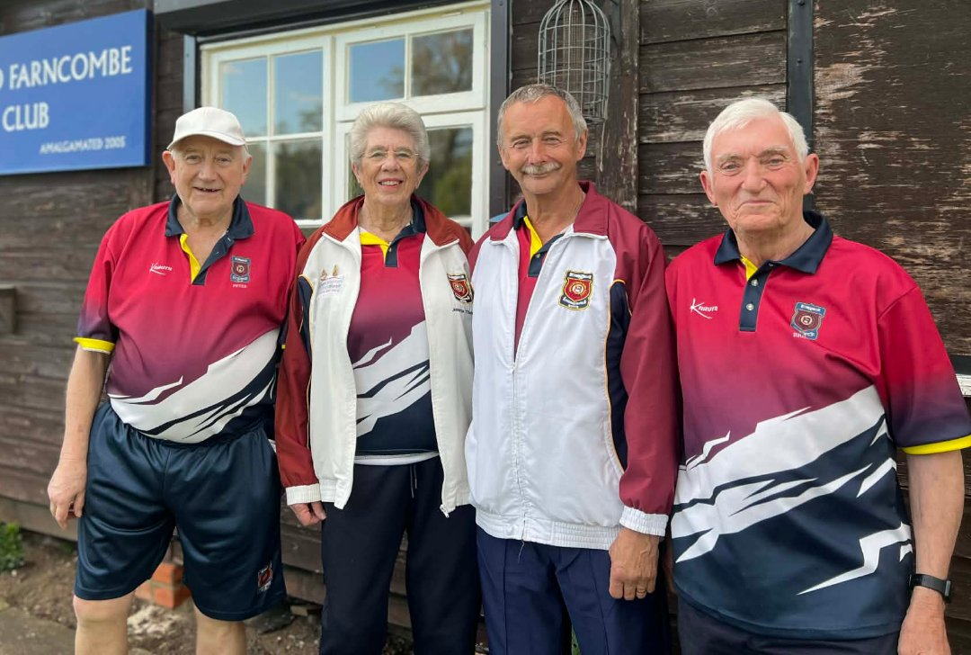
Wining team was Peter B, Brian, Jeanette and Jim (prize for the highest score)
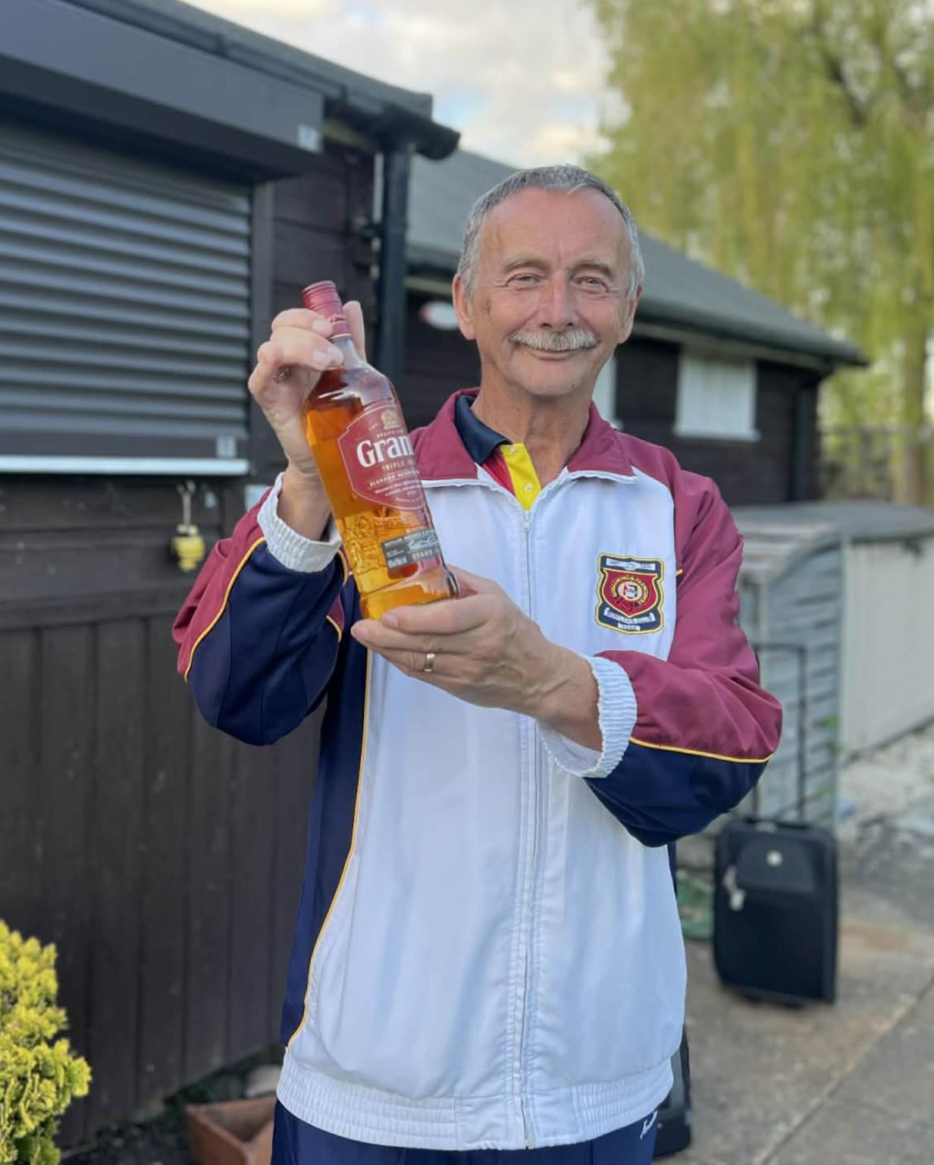
Matches,; all Friendlies have been won so far so a positive start to the season, keep it going.

Fixtures; The fixtures list is full for May, with many leagues starting over the next few weeks, except for the ladies league which starts on 1st June . The more names the better.

New system ; many thanks to Gareth for all his hard work and dedication. He stayed till 10 pm on Wednesday night making sure everyone was able to use the new system.

Club competitions ; closing date is 6th May @ 8pm. So if you haven’t already done so fill in the form by the door

Chelsea’s first Champion of champions match is a home match on Wednesday 20th May @ 6.30pm She plays Daniela Cousins. For those who want to come and support her.

Recruitment day ; You should have seen the Facebook advert for our recruitment day on 17th May. Please come and support your club and bring a friend.

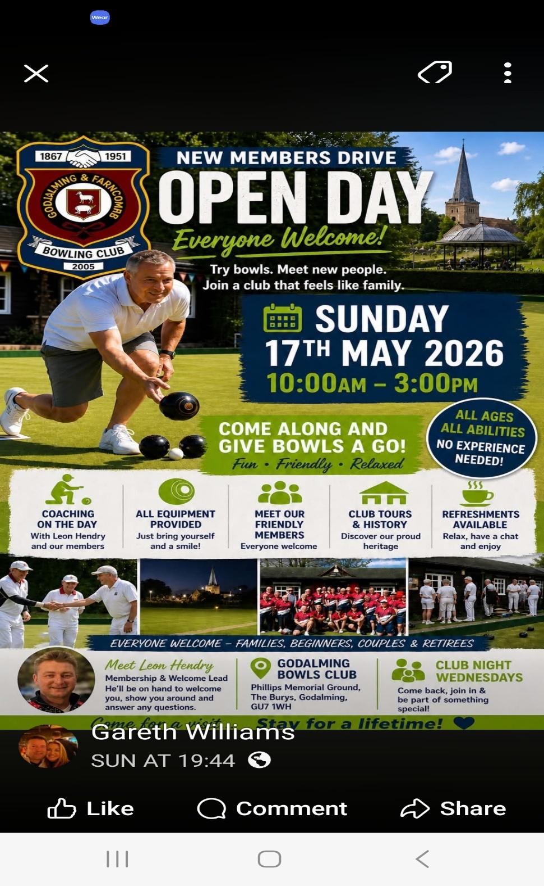
50/50club;
Results of Aprils draw below .
For more details please contact Martin Thomas

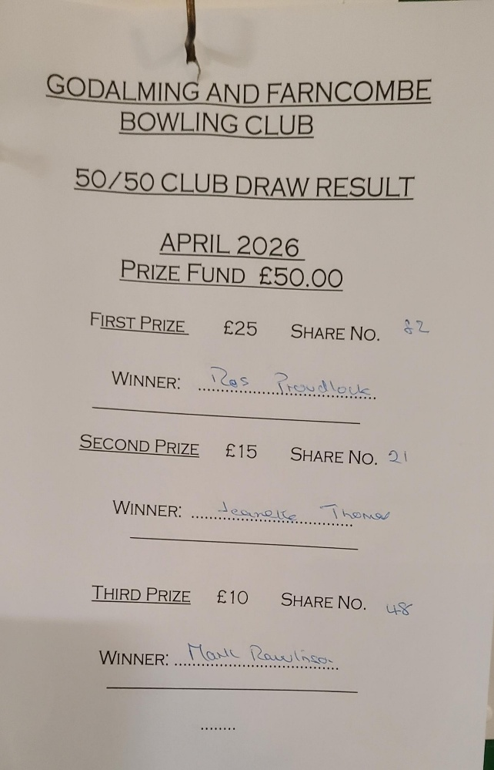
Rota’s ; tea and cleaning rota’s are in the club and under the members section on the portal you will also find it.
Want to add anything contact me:
(Clare MacFarlane ) 07825627536
m.macfarlane@sky.com

