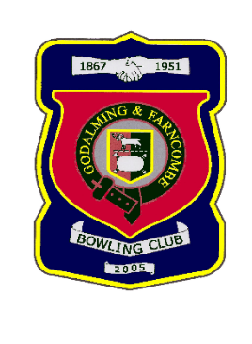 |  | Godalming & Farncombe Bowling Club  Selected team for  Three Counties President’s Cup  Wednesday 22nd July at 6.30 pm  AWAY v Clanfield
 | Robin Amy  Roger Humphrey  Nicola Gray  Skip: Jim Spring |  | Peter Mills  Jackie Spring  Les Easterling  Skip: Bernie Gray
Please contact Robin on 07411 913664 if you are unable to play
Thank you

