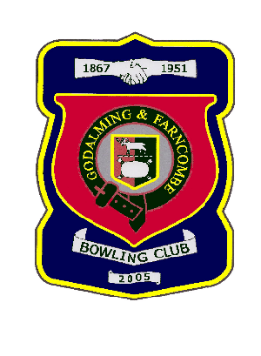 |  | Godalming & Farncombe Bowling Club  Saturday 25th July @ 2.30pm  Friendly  AWAY v Bognor Regis BC  Don’t miss the coach!!
1 | Mike Hobbs |  |  |  | 1 | Adrian Deuling
2 | Judith Davis |  |  |  | 2 | Jeanette Thomas
skip | Robin Amy |  |  |  | skip | Rob Boxall
1 | Dave Jenner |  |  |  | 1 | Lee Parker
2 | Roger Humphrey |  |  |  | 2 | Carol Bateman
skip | Bernie Gray |  |  |  | skip | Dennis Knight
1 | Les Easterling |  |  |  | 1 | Linda Rixon
2 | Sue Chruszcz/Monica V |  |  |  | 2 | Sarah Boxall
skip | Jim Spring |  |  |  | skip | Barry Honeywill
Reserves:
Andy Foreman
Captain of the day |  |  | Contact on
Robin Amy |  |  | 07411 913664

