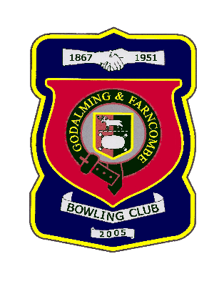 |  | Godalming & Farncombe Bowling Club  Tuesday 28th July @ 6.15 pm  Three Counties League  HOME v Rowledge A  Please report to captain of day by 6.00 pm
1 | Judith Davis |  |  |  | 1 | Adrian Deuling
2 | Jackie Spring |  |  |  | 2 | Les Easterling
skip | Bernie Gray |  |  |  | skip | Robin Amy
1 | Peter Mills
2 | Jeanette Thomas
skip | Jim Spring Michael Vernon
Reserves:
Carol Bateman, Dave Jenner
Captain of the day |  |  |  | Contact on
Robin Amy |  |  |  | 07411 913664

*Amended 2/7 – Jim Spring not available, Les Easterling steps up from Reserve list

